Make A Tatebanko Box
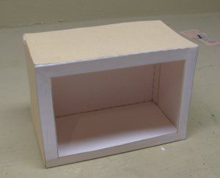
The Lost art of Paper Dioramas
www.StormTheCastle.com
Copyright©2009, All Rights Reserved

Tatebanko Box
This packet includes instructions and the six sides to make your own empty tatebanko box. This is if you want to put your own diorama scene inside. The general process for making a tatebanko diorama is to apply most of the various scene pieces to the base then add the back, the two sides, the front, then finally the top.
Recommendation: Regular printer paper is rather thin for a diorama. It is recommended you cut out the parts and glue them or glue stick them some type of very thin cardboard or card stock. Cereal box cardboard will work but is a bit thick. If you can find cardboard that is thinner it would be better. Also, manila file folders are perfect so you might want to use them as long as the manila color is ok.
This project is copyrighted©2009 StormTheCastle.com and Will Kalif. All Rights Reserved
Instructions for Assembly
Things you need for this project: This workbook, Scissors, Glue or Glue Stick, Thin Cardboard and some kind of tool to score the paper with.

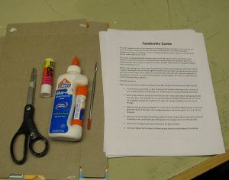

Cut out the six pieces for the box and glue them to your cardboard or card stock. Then cut them all out.
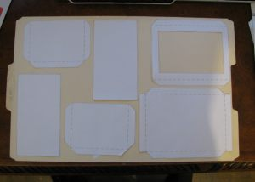
Now you would build your diorama on the empty base. Glue most of your created pieces to this before you assemble the whole box.
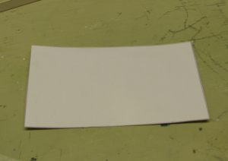
Once you have your pieces glued to the base you can build the box around it by starting with the back.
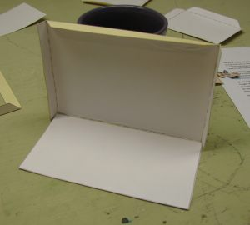
Now Glue the sides into place. Note how the tabs are in the front.
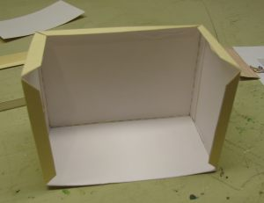
Glue the front piece into place.
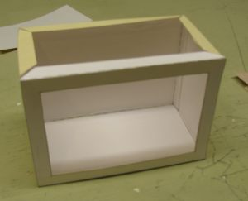
Finally, glue the top into place and you are done!
