Make a Tatebanko Castle

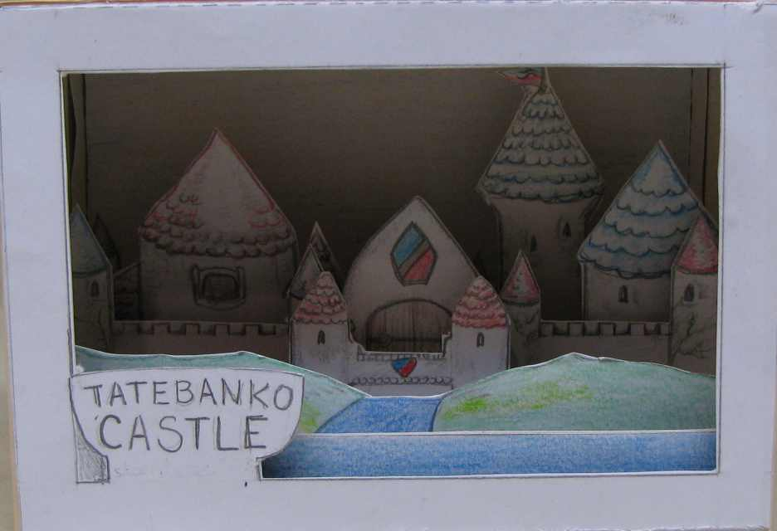
Everything you need to make a paper castle diorama
www.StormTheCastle.com

Tatebanko Castle
The art of Tatebanko is the ancient Japanese art of making dioramas out of paper. It was an almost lost art but it has seen a revival over the past few years. It is still difficult to find information about Tatebanko but things are changing. This Kit is a complete tatebanko project. It gives you everything you need to make a diorama of a castle.
This project is copyrighted©2009 Stormthecastle.com All Rights Reserved You can print this up for personal or classroom use without restriction but you cannot reproduce this project or post it to a website without express written consent of the author Will Kalif. Please email him through his website www.stormthecastle.com
What’s in this package? You have almost everything you need to make a tatebanko castle which includes 5 pages of drawings to cut out and put together and this instruction sheet. You will need scissors, glue or glue stick and some type of thin cardboard. Card stock really works well and Cereal box cardboard can be used but is a bit thick. To make the best tatebanko castle possible try to find a thin cardboard that is thinner than cereal box cardboard.
Assembly Directions: When cutting out the items a solid line means cut and a dashed line means fold. Do not cut the dashed lines!
Note: You can follow the numbers starting at #1 but after doing #12 do #14 next then finish with #13.
- I recommend you glue down, or glue stick down, the 5 sheets of drawings in their entirety to your cardboard before cutting things out. This will make the cutting and folding much easier.
- When doing a fold you should score the fold line with a sharp object before attempting the fold. This will make a nice crisp fold. You can use some type of a hobby knife but just be sure not to cut completely through the cardboard. The object of scoring is to deeply score but not cut through.
- Begin by cutting out the base labeled “1”. To this you cut out the numbered pieces in order and glue them down to the base in the numbered positions. Do this for parts 2, 3, 4, 5, 6,7, 8 and finally 8a.
- Next you cut out and glue the back piece #9 to the base. The glue tab on the bottom of piece 9 should be on the underneath side of the base #1. Do not glue it so it is on the top of #1.
- Next cut out and glue both sides 10 and 11 to the base and back.
- Cut out and glue the front piece 14 then last you should cut out and glue 13 to the top.

