Dinosaur Learning Sheet
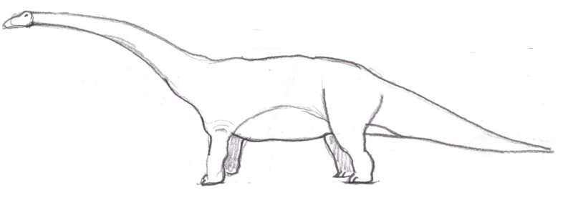
The Age of the Dinosaurs is known as the Mesozoic Era. This era lasted approximately 180 Million years beginning about 250 million years ago and ending about 65 million years ago. The Mesozoic Era is broken up into three different periods of time called the Triassic Period, the Jurassic Period, and the Cretaceous Period.
Dinosaurs themselves survived and thrived through most of the Mesozoic Era for about 165 million years until their extinction approximately 65 million years ago. They are categorized as belonging to two different families or branches. The first branch is of the Saurischia and the second branch is the Orinthischia. These categories are defined by the pelvis of the dinosaur. The Saurischian are lizard hipped and the Ornithischian are bird-hipped.
Dinosaurs were the largest, most massive and heaviest creatures ever to exist and some species like the Diplodocus grew to a length of 90 feet. But not all dinosaurs were large. They did come in a wide variety of shapes and sizes and the Wannanosaurus grew to a length of about two feet.

The Triassic Period
This period lasted approximately from 250 million years ago to 208 million years ago. It was the beginning of the Age of the Dinosaurs and during this time some of the dinosaurs that existed were carnivores like the Herrerasaurus and the Staurikosaurus. Herbivores appeared later in the Triassic period and some of them were the Plateosaurus and the technosaurus.
Some Triassic Period Dinosaurs:
Melanorosaurus, Mussaurus, Herrerasaurus, Pisanosaurus, Plateosaurus, Technosaurs, Coelophysis, Staurikosaurus
The Jurassic Period
The Jurassic Period marked the middle age of the Dinosaurs and it lasted from about 208 million years ago to 146 million years ago. During this period plant life was very abundant and this lead to an abundant of plant eating dinosaurs (herbivores) like the Diplodocus and the Stegosaurus. This abundance of plant eating dinosaurs lead to the growth and multiplication of many carnivorous (meat eating) dinosaurs. Some examples of this are the Compsognathus and the Allosaurus.
Some Jurassic Period Dinosaurs:
Diplodocus, Camptosaurus, Dryosaurus, Allosaurus, Acelidosaurus, Stegosaurus
The Cretaceous Period
The Cretaceous Period marked the final period of the Dinosaurs and it lasted from about 146 million years ago to about 65 million years ago. During this period dinosaurs evolved into a wide variety of species and more than half the currently known species comes from this period. Some dinosaurs from this period are the Tyrannosaurus and Iguanodon. It is at the end of this period that large dinosaurs became extinct.
Some Cretaceous Period Dinosaurs:
Saltasaurus, Torosaurus, Hypsilophodon, Tyrannosaurus, Deinonychus, Iguanadon

Extinction of Dinosaurs
We don’t know for sure how dinosaurs became extinct but there are currently two leading theories.
- A large meteor impacted with the Earth that caused a catastrophic climate change. In this climate change dinosaurs no longer could exist.
- A Super volcano or series of volcanoes erupted causing massive climate change.
It is believed that one of these events caused massive climate change on the Earth. One of the leading ideas is that the Earth’s atmosphere was covered over in a cloud that didn’t allow sunlight through. This lack of sunlight caused much of the plant life to die. With no plant life the herbivore dinosaurs died. And with no herbivores to eat the carnivores died too.

