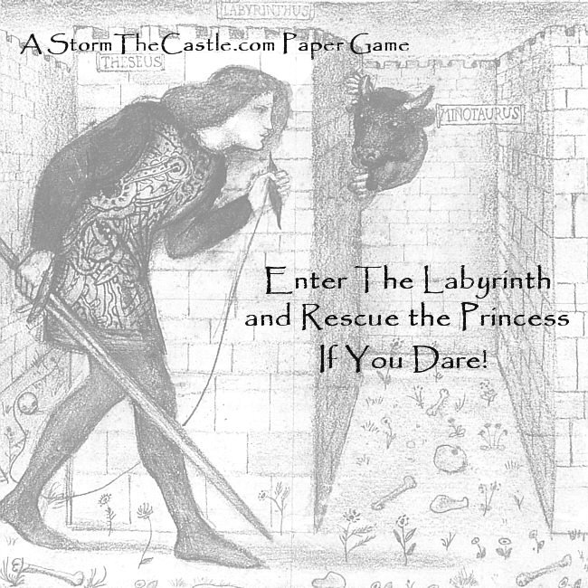
Enter the Labyrinth and Rescue the Princess
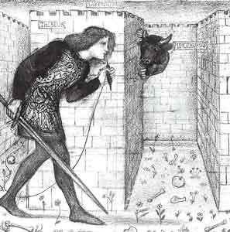
A free game brought to you by StormTheCastle.com This is a 1 or 2 player game
Print and assemble the game
There are three sections to this game. The first section is the game play board. The second section is the pieces sheet. It includes the player pieces, a six sided dice and some other pieces for the game. You should cut out all these pieces and glue them to thin cardboard like cereal box cardboard. You should also glue the player board down to cardboard for easier play. This way it will last much longer. The third section is the rules book. This is what you are reading now.
General Rules of Play
The goal of the game is to make your way through the Labyrinth until you finally find the Princess. But finding her doesn’t assure you will win the game. The Princess, as she got lost in the labyrinth has lost many of her possessions. You should find these possessions as you progress through the labyrinth. There are seven possessions in all and if you find six and bring them to her you are guaranteed to win the game. The fewer of her possessions you bring to her the lower your chances of winning her heart and the game. There is another option for winning the game. You see, there is an evil Minotaur lurking in the labyrinth. He is very strong (stronger than you) and you can fight him. If you win and bring his horns to the Princess you will have proven your courage and you will win the game regardless of the number of the Princess’ possessions you have found. But beware; it is difficult to defeat the Minotaur.
Be careful when wandering the labyrinth. There are many surprises and challenges. The longer you wander the labyrinth the higher the chances that something will find and defeat you – and you will lose the game.
How to play and use the rulebook
The game is simply played. You start at the start square and roll the dice. Then move your player piece the number shown on the dice. If you land on a square with a number on it then you refer to that number in the rule book and follow the instructions. Note that some numbers on the board are circled. These are positive numbers that will benefit you. Numbers without circles are dangerous but sometimes rewarding. Because it is a labyrinth you have the choice of going in any direction you want during any move. You can go left, right, forward and backward. But you cannot backtrack during any single roll of the dice. During a roll you can only touch a square once. If you want to go back you can do it on the next roll. Remember, during any one turn (roll of the dice) you can only touch any square only once.
Two Player Rules: Both players start in the start boxes. You roll the dice and high roll goes first. Then you take turns rolling the dice and moving your pieces. The game is won by the person who brings the most possessions to the Princess. There is only one copy of each possession so once a player takes it the other player cannot get it. So play smart and gather possessions quickly. In the case of a player being the first to bring four possessions to the princess first that player will automatically win for being first and having the majority of possessions, with one exception. The second player can still win the game if he faces and defeats the Minotaur then brings the Minotaur horns to the Princess. If a person collects at least four possessions, defeats the Minotaur, and gets to the princess then the game has been automatically won.
Occupying the same space: If a player lands on another players occupied space the the player who just moved gets to stay in the space. The player who was there first has to immediately move his player piece to one of the squares numbered 2 and follow directions for 2.
Moving past another player: The labyrinth is small and the corridors are thin but there is enough room for a player to move past another player. The occupied space does count though, you do not skip it. You count it as part of your roll move.
The Story
The Princess has wandered out of the castle and stumbled into a dark labyrinth that has many twists and turns. Along the way she has dropped many of her personal possessions. She is truly in need of the help of a brave knight. She will pledge her heart to whoever can recover her possessions and bring them to her or to whoever can slay the fiendish Minotaur that lurks in the Labyrinth. Are you ready to brave the labyrinth and rescue the Princess? The Princess believes in fairness and if more than one Knight has come to rescue her she will give her heart to the one that brings her the most of her lost possessions, or above all else she will pledge her heart to the knight that slays the evil Minotaur lurking in the labyrinth.

The Rule Book
When you land on a square with a number refer to this rule book and follow the instructions for that number.
Winning the Game
About the ‘X’ Square: This is the last square for you. It is where you must land to meet the princess. She sits on the princess square. You do not have to roll an exact number to land on this square. For example: If you need a 3 to land on this square and you roll a 3, 4, 5 or 6 you can advance to the X square and stop. All other squares in cul-de-sacs and in the ends of corridors you have to roll an exact number to land on them.
When you land on the “X” square you meet the princess. If you are playing a single player game you should have one or more of the princesses’ possessions with you. If you have six or more then you have won the heart of the princess and won the game. If you have less than six possessions you have to roll the dice. If the dice roll is higher than the number of possessions you have then you have not won her heart and must move your piece to the player start. But you keep all your possessions and continue with the game. But if you have the Minotaur’s horns when you land on the X square then you have automatically won the game.
The X square in a two player game: When landing on “X” in a two player game f you have the Minotaur’s horns you automatically win the game. If you have four or more of the princess’ possessions the other player must immediately advance to one of the squares numbered 1 and begin the battle with the Minotaur. If the other player loses to the minotaur you win the game. If the other player defeats the minotaur he must still advance safely roll by roll to square X in order to win. If he advances successfully to square X you are banished to square 2 forever and he has won the game.
NUMBERED SQUARES - INSTRUCTIONS
- You face the Minotaur – Get a scrap of paper and draw two columns. Put your name at the top of one column and write Minotaur at the top of the other column. Under your name write your health which is 20 points. And under Minotaur write its strength which is 30. If you have the magic axe then subtract 5 points from the Minotaur’s health before beginning. His strength will then be 25. To Battle the Minotaur. You get first attack; roll the dice and whatever number comes up you subtract that from the Minotaur’s health. Next you roll for the Minotaur and whatever number comes up you subtract that from your health. Continue taking turns until either your health or the Minotaur’s health goes down to zero or less. If your health goes down to zero you have lost the game. If the Minotaur’s health goes to zero you take possession of the token called Minotaur Horns and continue on with the game.
- You are trapped in a seemingly endless corridor, on your turn roll the dice.
- If you roll 1,2, or 3 you lose a turn,
- if you roll 4,5, or 6 you have found your way out and can advance your player piece to the start squares.
- You have found the Princess’ locket – take possession of the locket token. If another player already has it then you do not get it.
- You have found the Princess’ ring – take possession of the ring token. If another player already has it then you do not get it.
- You have been very sneaky, choose any token you want. If you are playing two player then you can take any token you choose from the other player. But in either case you may not take the Minotaur horns token.
- A giant spider has attacked you. Roll the dice; If you roll 1,2, 3, or 4 you have killed it and are safe. If you roll 5, it has bitten you and you must give up a token. If you have no tokens then you must go back to the start squares. If you roll 6 the Spider has killed you and you have lost the game.
- You have chanced into a lucky spot. You can choose any available token that is not already taken but not the Minotaur’s horns.
- You fall into a trap door that slides you all the way back to the start. Move your piece back to the start squares.
- You found the Princess’ bracelet. If the token has not been taken you may take it.
- You found the Princess’ diary. You have the option to read it or not read it and you have to make the decision on this turn. You cannot read it after this turn. If you opt not to read it then you just keep the token and move when it is your turn. If you opt to read the diary roll the dice and follow these instructions
- If you roll 1 or 2 you discover nothing, close the diary and move when it is your turn again but keep the diary token.
- If you roll 3, or 4 you have read something private about the Princess that you should not know. You must give up the diary token and move your piece to the start squares
- If you roll 5 or 6 you have read something about the princess that will help you to become her knight. You can choose any token that is not yet taken and still keep the diary token. But not the Minotaur’s Horns.
- You found the Princess’ money pouch. If the token is not already taken you may take it.
- You found the Princess’ Mirror. If the token is available you may take it. If another player has it you may not take it.
- You encounter a wandering zombie Roll the dice and follow these instructions:
- If you roll 1 the zombie kills you and the game is over for you
- If you roll 2 then you kill the zombie but not until after it has bitten you. You have zombie poison in you and you cannot think straight, cannot pick up any tokens. But you can take your turns as normal by rolling the dice. You have to get to square 14 which is where a gas coming out of a hole in the wall will cure you of zombie poison. Then on your next turn you can continue play as normal.
- If you roll 3,4 or 5 you have killed the zombie. Continue game play as normal
- If you roll a 6 you have slipped past the zombie unnoticed. Good job.
- There is a small hole in the wall that gives off a gas. If you are poisoned by a zombie the gas cures you. You can continue to play as normal.
- You found the Princess’ Hair Brush. If the token is not yet taken you may take possession of it.
- You find a magical scroll of teleportation. If you are playing a two player game you get to roll again. If you are playing a one player game you get to move any number of squares you choose up to 6 squares.
- You have made a big mistake and the Minotaur has spotted you! You must move your piece to one of the squares numbered 1 and then follow the directions for battling the Minotaur. But along the way you have found the Magic Axe and can immediately take it even if someone else possesses it.
- You have found the Magic Axe. Take the token if it has not already been taken. If another player has it you may not take it from them.
Thanks for playing Enter the Labyrinth and Rescue the Princess! Feel Free to pass it along to friends. The website is http://www.stormthecastle.com

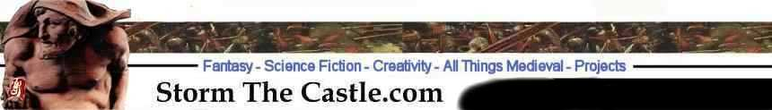

You are free to reproduce this game for personal use or to share with friends. You are not allowed to use this game in any format or any way with the intent of making money. You can post this game to your webpage as long as you make no changes to it and the links remain intact. And you must post an active hyperlink on the webpage where it is located or referred to. Make the link to http://www.stormthecastle.com For any questions contact the webmaster at stormthecastle.com Copyright ©2009 Kalif Publishing, All Rights Reserved.
