Helpers Guide to Making the Black Dragon Castle
Print up the 13 Page packet of Castle Parts. In the upper left hand corner of each of these pages is the page number. This page number is how I will refer to the parts of the castle.
Page 1: This is the floor of the castle! You simply lay this down on a table. It is a map for you to attach the various castle parts to. As you build a castle part you can glue it down or tape it down to this map. I recommend that as you build a castle part you just place it on the map (page 1) and do not glue or tape it down right away, wait until you have all the parts built and placed before you tape them all down.
Page 2:
This sheet is the two front towers. The sheet itself has the template to make one tower. Make a copy or print up a second copy and make two towers with it. Cut out the shapes and attach them to a bathroom tissue tube.
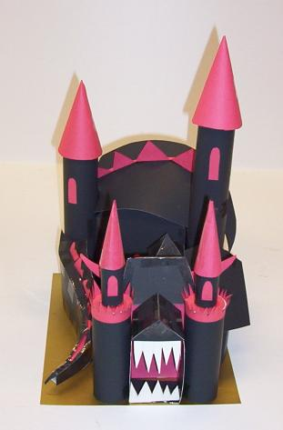

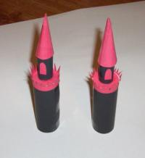
This is what they will look like when you are done. Now you can place them on page one in the positions labeled tower 1 and tower 2.

Page 3 – This is the main gate. Cut it out and assemble it as shown below. You can place it on page one in the spot called Main Gate.
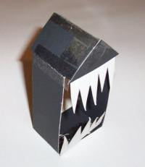

Page 4: This is the gatehouse – cut out the pieces and assemble it so it looks like this. Place it on your page 1 in the position called Gate House.
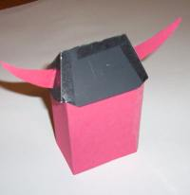
Page 5: This is the neck of the dragon.
Cut out the two pieces, fold up the building part and tape it together then tape the roof to it. The roof has somewhat of a bend in it and make sure you have it oriented in the way shown in the picture. Once assembled, place it on your page one in the position labeled (3 Dragons Neck)
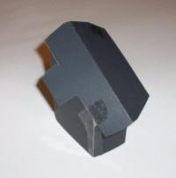

Page 6: The Dragons Shoulder. This is a one piece assembly, cut it out and fold it into the shape of a tower then place it on your page 1 in the location labeled (4 Dragons Shoulder)
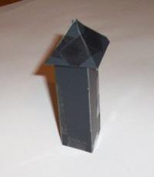

Now you are going to make the dragons body.
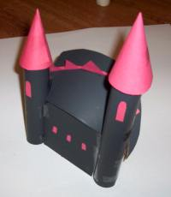
Page 7 Dragons body, base and front This sheet page seven is the front and base of the dragons body. Cut out the shape and transfer it to black construction paper. Now, orient it the way it is on the page. The two dots are in the upper left furthest away from you. The dotted line goes roughly across the middle from left to right. Now place you hand on the top section holding it down on the table. Then grab the bottom of the paper and fold it up along the dotted line.

It should look like this:
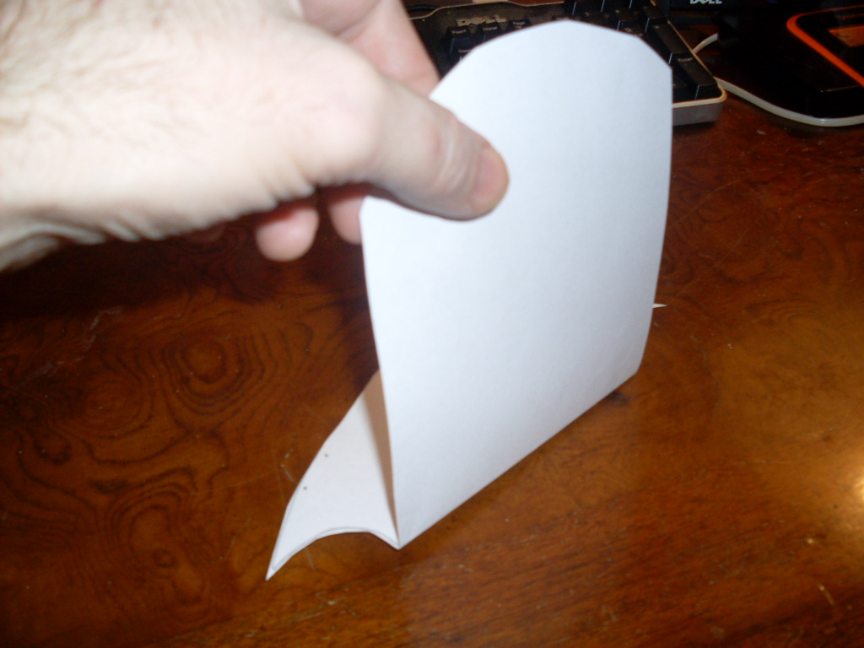

Once you folded it you cut out page 8 and tape it to what you folded from page 7. Make sure the dots line up. It should look like this:
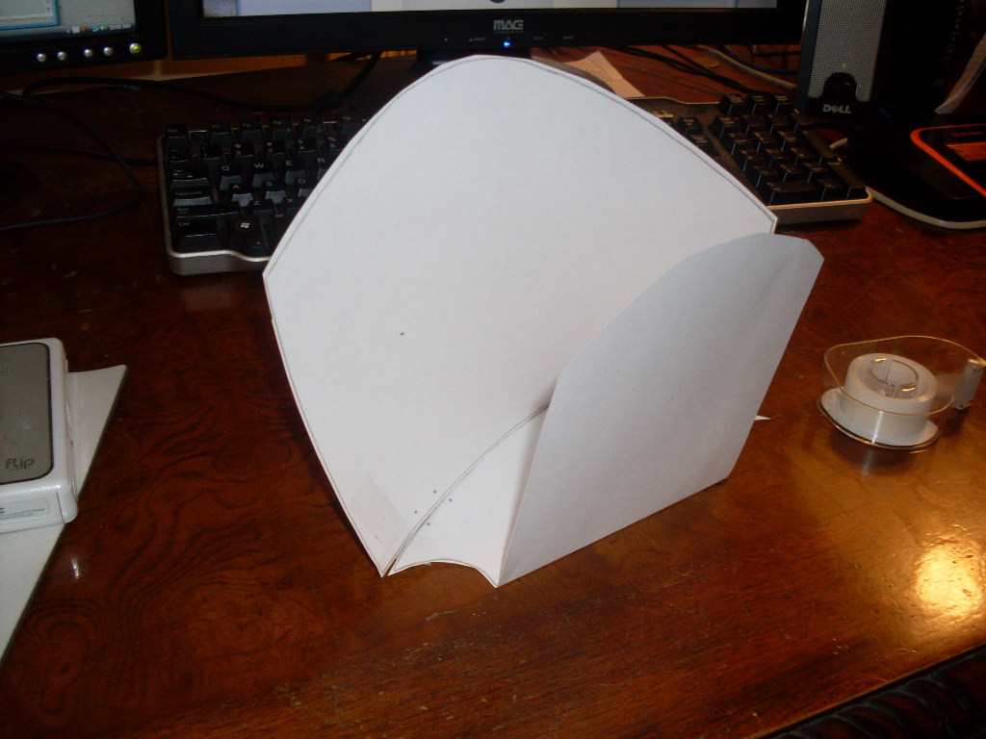
Now cut out page 9 . This is the roof of the dragons body, but you don’t put this on yet. You should assemble towers 3 and 4 and attach them to the dragons body first. Then you can put the roof from page 9 on.
Before you put the roof on it looks like this:
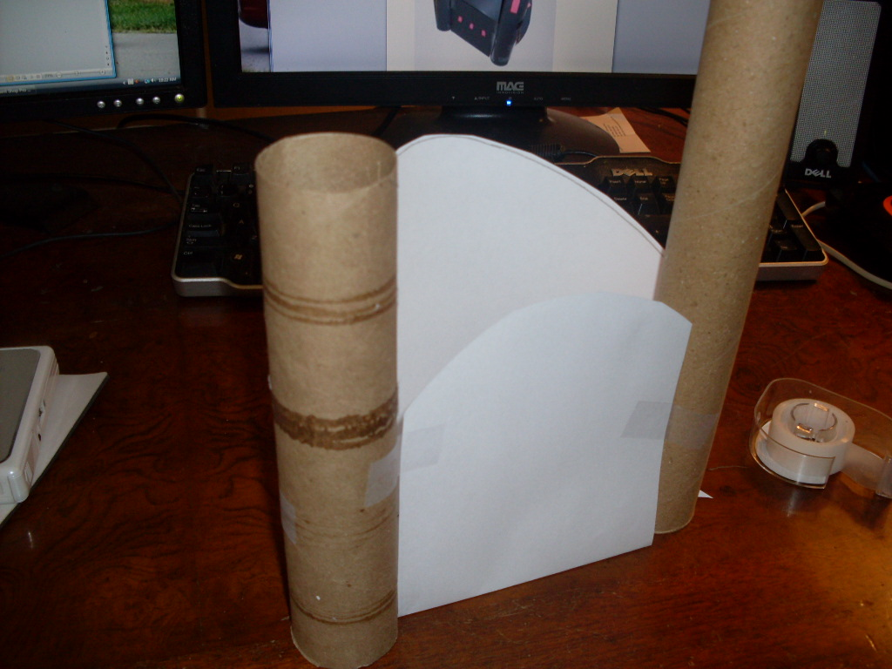
You should build towers 3 and 4 which are pages 10 and 11 now and attach them to the dragons body then tape the roof on which is page 9. Cut out the turrets on page 12 and using red construction paper attach them to the tops of the towers 3 and 4.
Once the roof is on it looks like this:
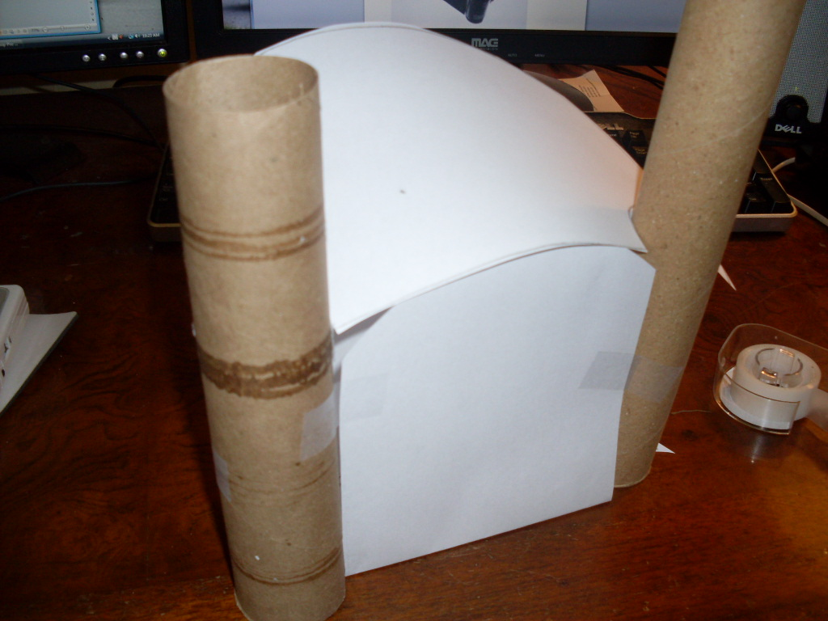
You can tinker around with this. Because it is a lot of curved shapes it will be tricky to assemble. You can make little cuts and trim it as you need to.

Add some details like windows and the dragons spine and it should look like this:
Put this down on your page 1 and lets continue on.

Page 13 is the dragons tail. Cut out the shapes and assemble them so they look like this:
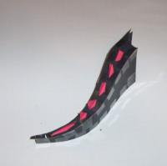
Place it on your page 1. You have built all the sections of the dragon castle now move all the pieces around and arrange them so it looks nice and neat. Once you have it the way you want it you can then tape everything together and everything down to the page 1 map.

