Fun learning examples for the Paper Medieval Castle you made

Medieval Castles were an architectural style that developed of several hundred years during the Middle Ages. They were a necessity to keep the people inside safe from enemies and they developed many ingenious ways of defense.

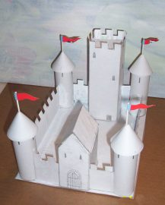

The Moat: Castles often had a moat around them. But this wasn’t because it made it hard to cross over. The moats main purpose was to prevent enemies from tunneling under the castle. The water would flood any attempted tunnels.

The Gatehouse: The front door of any castle was usually the weakest point and the gatehouse was a way to fix this problem. It was very strongly built, with thick walls and often had a series of doors and gates. If an enemy broke through the first door they were in a little chamber where the castle residents could throw projectiles and fire arrows down on them. The gatehouse was a very big trap!

The Round Towers: In later centuries of castle making they made the towers round and this was a big advantage because the people in the towers had a better view of the ground. Square towers caused corners that couldn’t be looked around.

The tall think windows: These were made so defenders could shoot arrows and still remain reasonably protected from attack.

The Big Tower Keep: This was a strong safe building inside the castle and was the last resort where the castle inhabitants would go if the outer castle wall was breached.

The Battlements along the top of the walls: These strange tooth shapes at the top of the castle walls were very important. It allowed people to stand on the wall, look down and still be protected.

