Make A Paper Castle

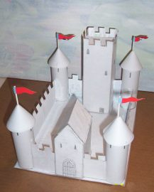

This project is a paper based project for making a castle. This instructional booklet gives you everything you need to make the castle shown above. You just print everything up. The pages that you assemble into the castle begin on page 5.

Copyright Notice: Copyright © 2008 Kalif Publishing , All Rights Reserved. You are free to print this project for your own purposes and to share it with others. You can print multiple copies for educational purposes. But you cannot post this project to your website or ebook or any other type of distribution method without express written consent from the author. For more information contact the webmaster for http://www.stormthecastle.com

Step 1: Printout and cut out all the various shapes from the booklet of parts. Glue these parts down onto the cereal box cardboard. Once the glue has dried you can then cut out the cardboard shapes. Leave the paper on! You may want to glue the paper to the colored side of the cardboard. It will hide the color and will make painting the castle easier. I show here that I glued to the plain inside of the boxes.

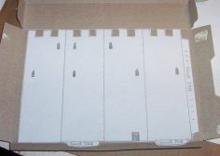

When gluing the castle parts to the cardboard use a liberal amount of glue all over the cardboard but keep it thin (not big globs or lines) and use a cotton swab stick to spread it around.

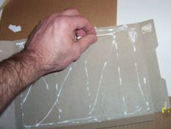

Glue the tower walls to your four tower tubes. They should be four and a half inches tall. Cut out circle tower tops and fold them into cone shapes. use a very small amount of glue to do this. Finally, apply glue to the top of the towers and glue the tower cones on top!

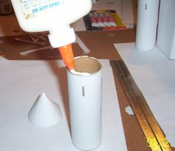

The tower is completed. Hold your finger on it for a minute to allow the glue to take a firm hold.

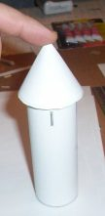
Bending Tip: When bending the various sharp edges of your castle use a rule or a piece of wood. It will help you keep all the edges straight and sharp.

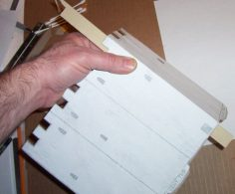

Now cut out the tower keep, tower keep roof, and the gatehouse. Fold them up and glue them. Glue the roof of the keep into the tower keep. I folded the keep but didn't glue it closed, I then glued three edges of the roof into place and finally glued the tower closed.

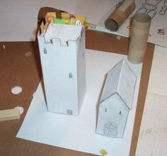

Now you are ready to glue all your parts to the base of the castle. You should have a keep tower (biggest) a gatehouse, 4 round towers, and 6 tower wall sections.

For the best looking results you should glue the parts to the base in a linear sequence something like I have shown here. Glue the tower labeled 1 down first. Then glue the wall section (2) to it. Then glue the gatehouse, then section 4. Continue all the way around until you are done. Doing it in sequence like this will give you the best results in look.

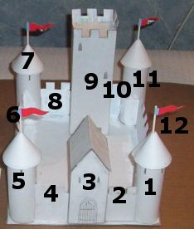

Finally, Cut the tips off the tower tops and glue a toothpick or trimmed cotton swap stick into it. These are the flag poles. Finally glue your flags onto the poles. (Paint or color the flags first!)

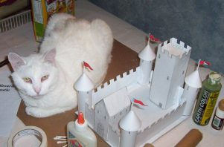

Where Do we go from Here? Have some fun painting and decorating your paper medieval castle. You can also glue lots of things to it like string, yard, glitter or even macaroni!

The Paper and Cardboard Medieval Castle – Parts of the castle

There are seven pages of drawing for you to print out. Print them out, cut out the
shapes and glue or paste them to your cereal box cardboard. Once the glue has dried you can cut
out the cardboard shapes.

About printing and sizes: Your printer or your Word program may cut off a little
bit of the images along the sides, top and bottom. Don’t resize the pages or the images it will change
the scale and the parts won’t fit together correctly. You should print them out and then touch
up the drawings with a pencil. If you still are having trouble you can just
print out the seven jpeg pictures I have included with the tutorial. Print out those pictures
and cut them out and paste them to the cardboard.

A quick way to check if the scale of your printing is correct is on the last two pages
of this booklet called “The Tower Walls” after the print them up the square shapes
should be almost exactly 5 inches wide and 4 ½ inches tall. If your printout varies from
this by more than an 1/8 inch you need to check your printing settings or document settings.

Pages In this booklet

Intro page ( you are here!)
Castle footprint (Base of the Castle)
Castle Keep (Big tower in the back)
Castle Walls
Castle Gatehouse
Keep Roof, Flags, 1 more wall
Tower Turrents (cone shaped)
Tower Walls
Tower Walls

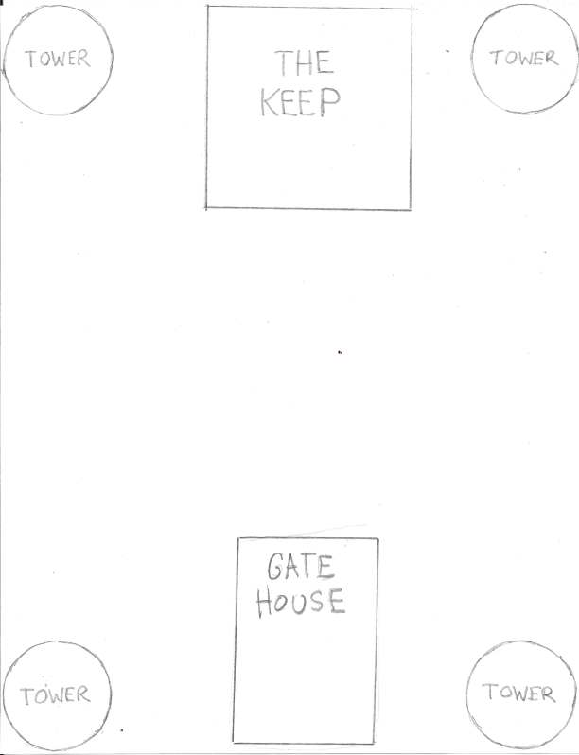
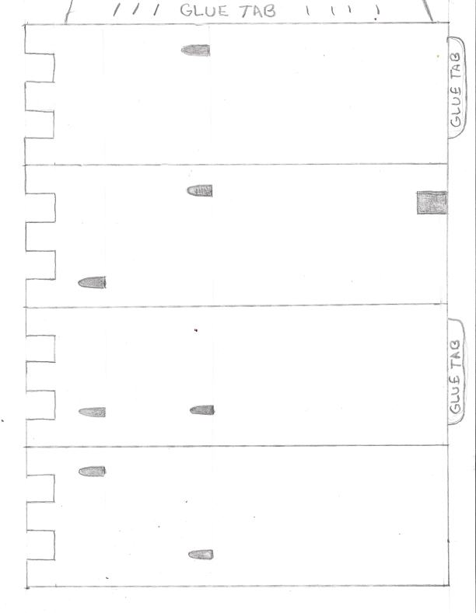
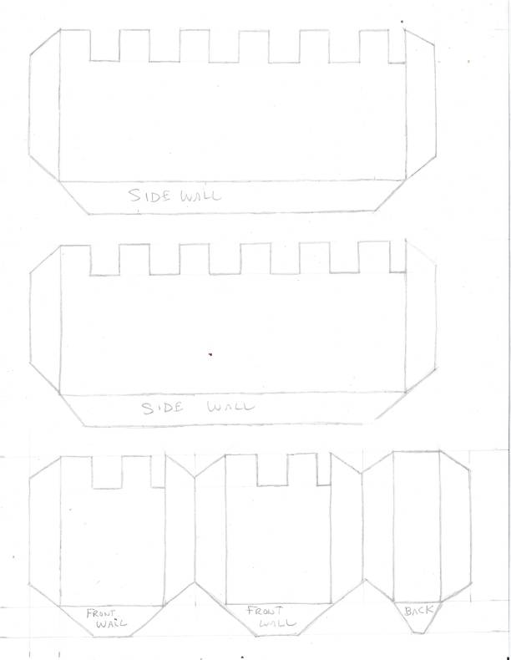
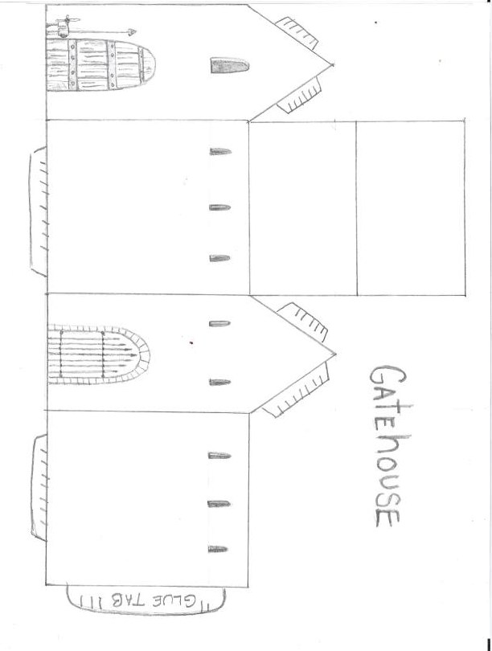
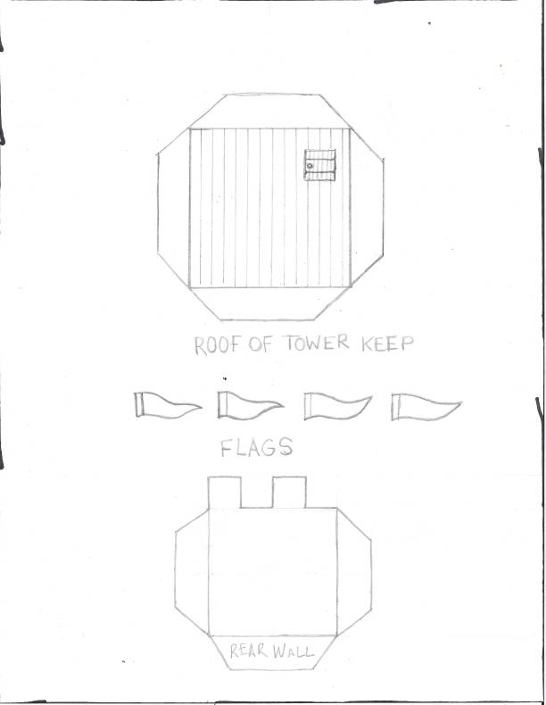
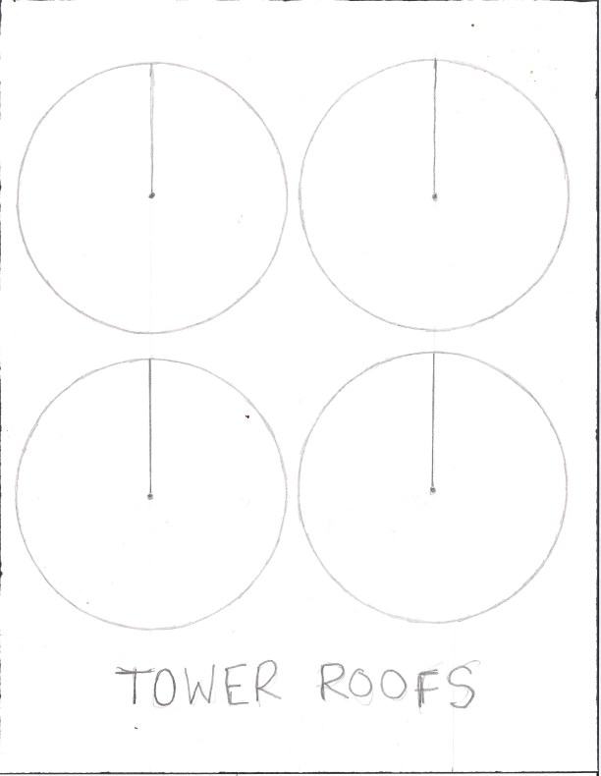
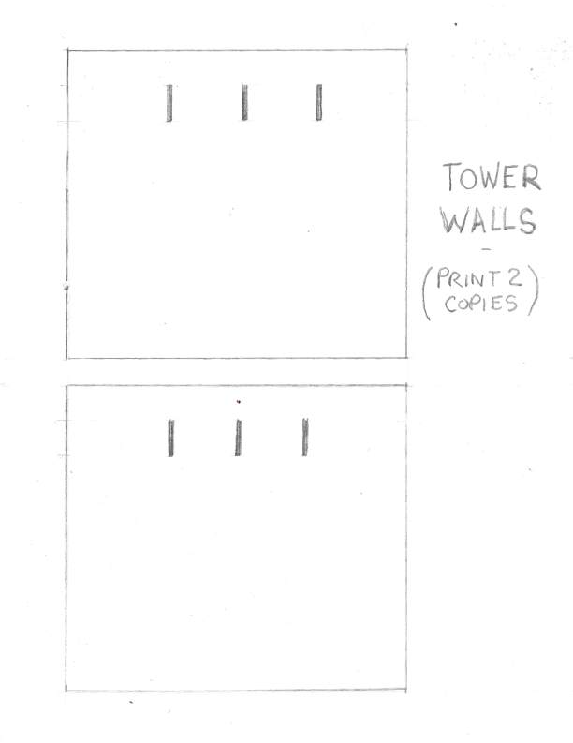
All Rights Reserved – For More fun projects visit:
http://www.stormthecastle.com

