How to Make a Paper Castle
(The Famous Neuschwanstein Castle in the Clouds)

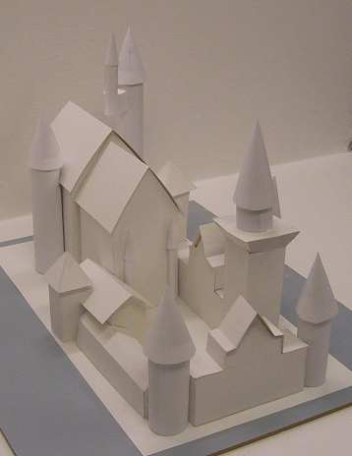

This is a complete tutorial with all the necessary items printable. So you can print it up and make it yourself.
You will need cardboard or posterboard and some simple tools/materials.
I have other Paper castles you can make on my website:
www.StormTheCastle.com
You can see this on my youtube channel:
http://www.youtube.com/epicfantasy
I also have this project in a web based tutorial here:
http://www.stormthecastle.com/paper-castle/make-a-paper-neuschwanstein-castle.htm

This castle is a bit more challenging than my first castle but it is still pretty easy.

What I have done is broken it down into small sections so all you have to do is make each small section one at a time and affix it down to the base. And everything is geared to a sheet of paper that is 8 1/2 by 11 so you can print it up on your printer. The reason why this castle is not that hard yet looks really good is because I have broken it down into building each of the structures one at a time then gluing or taping them down to the base. There are no complex or difficult to understand folds. And it still looks quite beautiful but I can't really take credit for that. That credit goes to the architect who designed the original Neuschwanstein!

** Print up this document** All the pages you need to make the castle are the last pages. You should set the borders for printing to zero. All the pages are 8 ½” by 11”. This means that you may need to touch up some of the drawings by completing the drawings at the edges.

How you do it!

The last pages (17-42)of this document are all the castle parts. (You can save paper and ink by just printing up 17-42 and reading instructions pages 1-16 on your computer)You glue these down to posterboard or cardboard (Cereal boxes works great) You then cut them out and fold them. As you make each component of the castle you affix it to the base footprint of the castle.

About the cardboard or poster board

You can use either poster board (you will need 3 of them but get 4 just in case) or you can use cereal boxes and depending on the size of the box you should be good with 6 of them.

About fixatives and glue

This project is designed for you to print out a sheet, affix it to your cardboard then cut it out. This is the best way to do this. And you have several options for affixing to the cardboard. You can use glue stick which works the best. You can also use paste which works great. Or you can use common white glue which works fine but just make sure you use it very sparingly. If it gets globby it will tend to wrinkle your castle. Nothing worse than a wrinkled castle!!

Coloring the Castle - I have left the whole castle blank and it looks really great this way but you may want to color and decorate your castle. I recommend you do this with the plain print outs either before of after you glue them to the cardboard. Once the castle is built it is very hard to decorate with pencil or crayon. But you could do some decorating with watercolors after it is built. I have a learning sheet about this castle and pictures so you can make it more authentic by painting or coloring it the way the real castle is.

The Castle Base: It would be better (for strength) if you can glue the base of the castle to a thicker corrugated box type cardboard. If you don't have any then cereal box cardboard will be fine.

Extras: Here are some suggestions for making your cardboard and paper castle better.

Add a blue construction paper moat around it

Make another building and add it into the model.

Add small toy figures

Paint a small garden on the inside of the castle

Paint the courtyard a dirt or sand color

I have a teeny tiny catapult project that you can build and storm this castle with! On my website here

Okay! Let's Start Building This Paper Castle

- Materials you need to make this paper castle
- 3 paper towel tubes
- 2 bathroom tissue tubes
- 3 sheets of poster board or 6 cereal boxes
- white glue, glue stick, or paste
- Cellophane or masking tape
- Scissors
- Ruler
- A Pencil
- Colored pencils, crayons or water colors (optional to decorate your castle)

***I recommend that as you build each building unit you affix it lightly to the base with just a piece of tape or two for now. And continue doing this. Once you have all the pieces completed then you can look at it and tweak it around a bit before you glue or tape it down permanently. This will also help with the small differences between your castle and mine and with variations in printers and how the pages are printed.

These three images are the base of the castle. Print them out and tape them together then tape or glue them to a nice solid piece of cardboard. You can tape them to posterboard but something more durable and stronger would be better so it is easier to move and carry your castle. You will be gluing the parts of the castle right onto this base.

Base A - Base B - Base C

When they are taped together they should look like this:

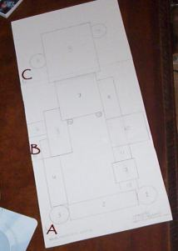

There are seventeen numbers on this base. These are the different structures you will make and in that order. We will make all 17 starting at 1.

Lets Make Structures 1 and 3. These are the two round towers in the front of the castle. You need two bathroom tissue cardboard rolls for this, or you can cut a paper towel roll so you get two tubes that are 4 and 1/2 inches long.

Cut out some paper and cover the tubes with it then cut out some more paper and make the cone shaped tops. I have created a picture of this that you can print out and use . The pictures are labeled Tower Wall/Tower Top and there are two of these pages to make both towers. - Remember that your bathroom tissue roll may be slightly different than mine so adjust the size of the paper and of the turret so it looks nice.

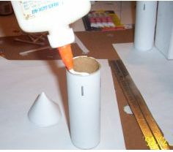
Glue or tape the paper to the tube and glue the turret top to the top of the tower.

You can decorate your towers while they are still sheets of paper or after you build them. I have put a few simple archer slots in my towers.

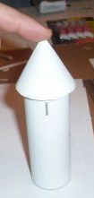

Hold the turret in place for a minute so the glue takes hold.

Do this whole process twice to make the two towers in the front of the castle. They are at positions 1 and 3. Tape them down to the base of the castle.

Lets Make the Gatehouse (Item 2 on the castle floorplan)

The Gatehouse is the page labeled The Gatehouse –2 . Solid lines are where you cut and dashed lines are fold lines so don't cut them!

It is composed of two halves and they are pretty easy to fold together into the gatehouse. This picture gives you an idea of how to assemble these two halves together.

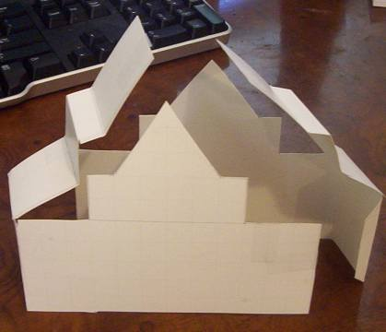
Now attach this piece down to your castle footprint at position numbered 2. Just secure it with a small piece of tape or two. This way you can adjust its position later.

The Courtyard Wall (4)
Cut out and fold up the Courtyard wall labeled (4) affix it to your cardboard or posterboard, cut it out and fold it so it looks like the structure in this picture. Then affix it to position 4 on your castle floorplan.

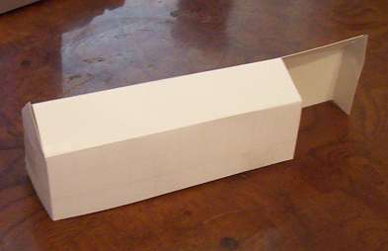

Now lets Build the Servants Quarters 5. It will go into position 5 on your Castle Floor Plan.

And this is what it will look like when you have completed building it.

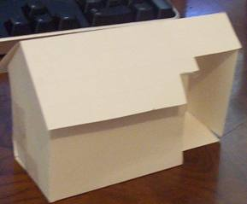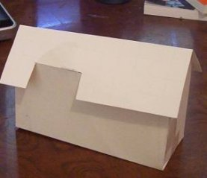

Now let'ts add the servants tower (6).affix it to cardboard, cut it out, fold it up then attach it to your castle floor plan. Here is what it looks like when you have completed it.
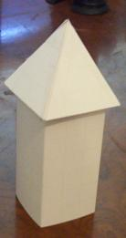

And here is a picture that shows how it will nestle into the servants quarters.

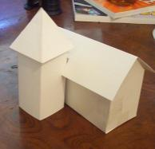

Now lets Make structure 7 (The Knights Quarters)

This structure is composed of two parts:

The Knights Quarters Building (2 pages of this) and assemble them together

The Knights Quarters Roof – (1 page) and affix it to the top of the building

Here is what the Knight's Quarters looks like. In my picture I have already added the two thin towers. You haven't done those yet and don't worry about them for now. We will do them later. Notice how the slot in the roof is on the right side of the building.

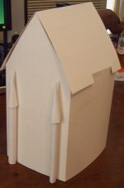

Now lets make Structure 8 (The King's Quarters) This is a pretty big building so I had to break it up quite a bit to fit it onto sheets of printer paper. Apply all three of the pages to cardboard then cut them out and build the structure.

Two pages each of these:
Kings Quarters 1
Kings Quarters 2
And there is one page of this:
Kings Quarters Roof

The picture below shows how the building should look when you are done. Affix it to your Castle Floor plan in position 8.

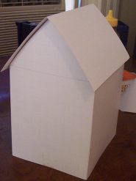

Now Lets Assemble the Knights Tower (This will go in position 9 on your Castle Floor Plan)

There is one page each of these:

The Knights Tower
The Knights Tower Roof

Assemble them and place them on your floor plan as shown in the pictures below. The first picture shows the assembled tower and the second picture shows how it stands right up against the Knights Quarters. And notice how it fits nicely into the slot in the Knights Quarters Roof.
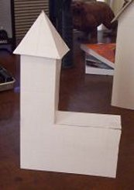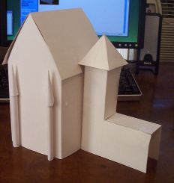

Now let's make the Guest Quarters (10):

These are the pages for this:

Guest Quarters
Guest Quarters Roof

Print them out, affix them to your board or cardboard and build the guest quarters. It should look like the picture below. When you are done gently tape it to your Castle footprint at position 10,

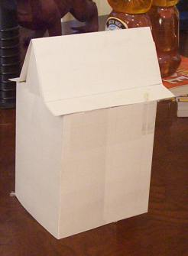

Now let's do the Courtyard Walls 11 and 13.

These are on the same sheet of paper so there is only one page. Cut them out, affix them to your cardboard then assemble them and affix them lightly to your castle footprint. The Guard Tower (12) will go between them so you may need to move them a bit once the Guard Tower is in place.

Here is what they look like: ( 11 is on the left and 13 on the right)

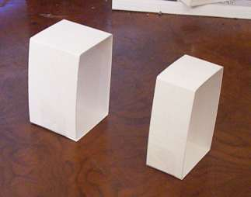

We are getting close to finishing this castle. Hang in there. Next we do the guard tower then a couple more towers and we are done! Continue with this paper castle

Now lets Make structure 12 (The Guard Tower)

The Guard Tower (12) This is the most spectacular looking part of this castle and it is a little bit of a challenge to make. That is why I have saved it for last.
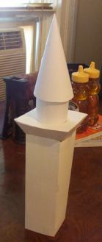
The Guard tower is made up of four different components and take a look at the paper towel tube. Cut your tube to nine inches long then cover about 5 inches of it with a wrap of paper. My tube has been wrapped.
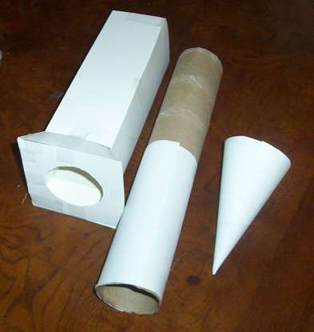

Once you have built the parts like I have shown in the picture you just slide the tube into the hole at the top of the square piece then add the turret and you are done.

Here are the pages for this tower:

The Square section 1 page (Guard Tower 12)
The Top section 1 page (Guard Tower Top Part 12)
The Cone Turret 3 pages (tower Turret for 12, 14, and 15)

You need three of the Cone turret because this is the same turret you will add to the Guard House you are doing now and to the towers 14 and 15. So make all three right now.

Once you have finished making the Guard Turret You can affix it down into position 12 on your Castle footprint.

Towers 14 and 15. You have already made the cone turrets for these now you just have to make the towers. This is pretty straightforward except for the additional little section on the big tower.

My towers are cut out a bit so they rest up against the buildings. But you don't have to do this if you don't want to. You can just wrap the tubes in white paper and place them against the buildings - it's your choice.

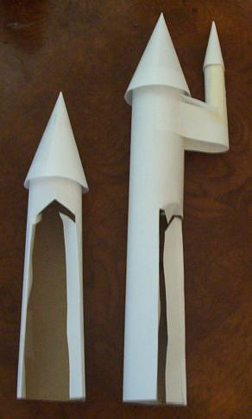

The size of the towers:

The tube for tower 14 is 7 1/2 inches in height
The tube for tower 15 is 11 inches in height.

Now you just need to make the mini-tower and attach it to tower 15.

affix it to cardboard and then shape it and attach it near the top of tower 15 – (ini Tower that attaches to 15)

To finish up this castle you need to add the thin towers to the Knights Quarters (7) The tube part of these towers is four inches high. You can make them by rolling some paper around a pencil and then taping it into place. Then make the cones for the top using a shape similar to what you did with the previous cone turrets.

Well, This was quite a fun castle to make and I really enjoyed it. If you made this castle I hope you had fun and send me a picture I would love to see it! If you haven't done any coloring it might be time to break out the water color paints and start having fun!

Lots more fun stuff on my website at: www.StormTheCastle.com

THE FOLLOWING PAGES ARE THE PRINTOUTS FOR THE CASTLE

