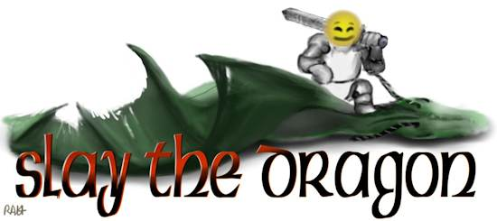
Graphic by Ruth http://loveablemoggy.deviantart.com
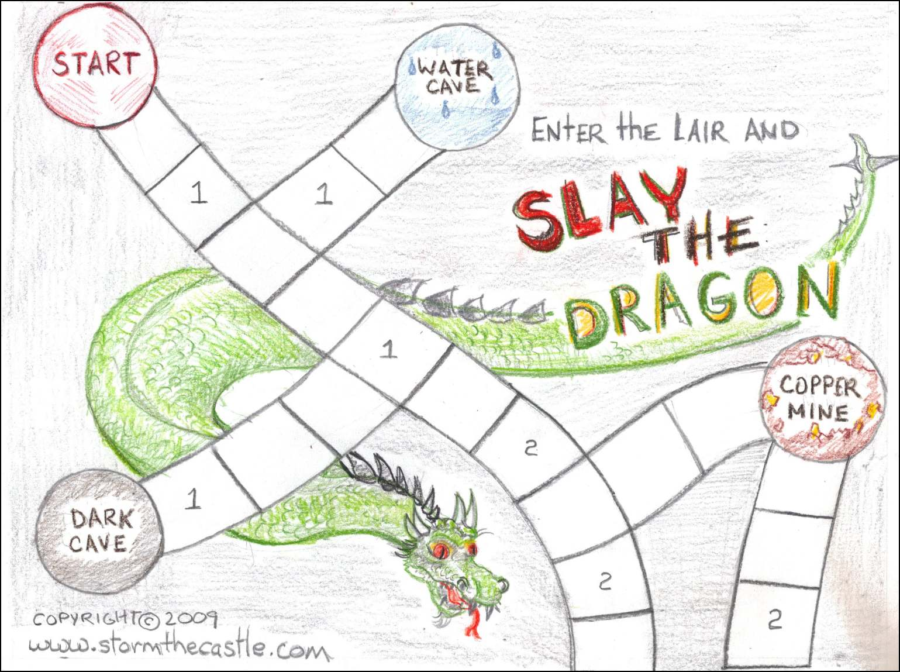
A Print, Glue, and Play Paper game by StormTheCastle.com
Slay the Dragon
A Print & Play Paper Game from StormTheCastle.com This work is copyrighted ©2009 www.StormTheCastle.com. All Rights Reserved. Please feel free to print this up, make and play this game but do not distribute it in any means without the express written consent of the creator.
The Story and Object of the Game:
The Kings Daughter (The Princess Arabella) is of marrying age and the King wants to find a suitable husband for her. He has to be someone of courage and valor. So the King, in order to find the right person, has issued a challenge: Slay the Evil Dragon Drachobon and bring the King one of his scales.
The princess is truly a beautiful and wonderful woman and you want her hand in marriage. If you can slay the dragon the King will promote you to the rank of honorable knight and give you the Princess’ hand in marriage. Are you up to the challenge? It will take strength, courage, and brains to accomplish this feat.
How to Make the Game:
This game is composed of three parts. First there is the instructions and Game Manual, second there is the Game Board which is two sheets in size, and third there are the game pieces. Print up this whole package. Then glue the game board and game piece sheets each to a sheet of cardboard. Cereal box cardboard works well for this. Tape the two game boards together so they form one large game board then cut out the game pieces and you are ready to play. There is an included dice if you need it, simply assemble it and glue or tape it into shape.
Game Play and Objective – Your objective is to get to and slay the dragon. The game starts out with you on the Start Circle. You roll the dice and move your game piece the number of squares shown on the dice. It is your choice how directly you want to go to the dragon. You can go directly toward him or you can explore the various tunnels and caves along the way. If you land in a square with a number then look up that number in the RuleBook and follow the instructions. When you land in a cave you look up that cave in the RuleBook and follow the instructions.
General Rules of Play – You roll a dice and move your player piece the number of spaces shown on the dice. You can move in any direction you want but you cannot change directions in a single turn. In other words you can’t go forward a few spaces then back a few spaces in the same roll of the dice. When you land on a square with a number or a letter in it you should look in the game book to see what you should do. Generally this means combat with a wandering monster.
Landing in a Cave – Caves are round circles on the playing board that have names such as Copper Mine or Water Cave etc. You do not have to roll an exact number to land on one of these caves if your roll takes you to the Cave space you can stop there and begin the adventure in that cave. Look to the rulebook to see what you should do for each cave. Each cave holds a challenge and a reward. And the deeper into the Lair you go the harder the challenge but the better the reward. Once you have cleared out a cave it remains empty for the remainder of the game. You cannot return to it to get another bonus.
General Rules of Combat - You begin the game with 50 health points and an attack of +3. As you adventure through the dungeon you will acquire items that will modify this. These items can be used for the duration of any battle and you can decide to use one or more of them at the beginning of a battle or in the middle of a battle. But, once you have used one you must turn it in and it will not be available to you in future battles.
Battle System – Write down your health (50) and your attack (+3) on a piece of paper. When landing in a cave or encountering a wandering monster the rulebook will tell you what your opponents health and attack are. You write these on the paper too. You begin battle by rolling the dice. Whatever number comes up you add your attack to it (3) and then subtract this number from your opponents health. Then your opponent rolls the dice and you subtract this number from your health. If the opponent has an attack modifier make sure you add this. So if your opponent rolls a three and has an attack of +2 you subtract five from your health. The battle is over when you or your opponent’s health goes down to zero or less. Once the battle is over, if you won, your health automatically goes back to 50 and your attack to +3 so you are ready for the next battle.
More about using Tokens: You can amass tokens that modify either your health or your attack. These can be used in any battle but only once. A token lasts the duration of the battle and must be turned in. And you can decide to use a token at any point during a battle. You cannot return to a cave to get another token. And you can use as many tokens as you possess during any combat. If you have a token that adds 10 to your health and a token that adds 20 to your health you can use them both in a single combat if you like, thus adding 30 to your health. Or you can use any combination of tokens that you want including mixing health and attack tokens. But, when a battle is over you have given up any tokens you used and your health resets to 50 and your hit modifier resets to +3.
Tips on Game Play – this is a game of courage and risk. There are things in the Dragons Lair that will help you battle the dragon successfully. But, the more powerful the item the more risk there is in getting it. So you have to weigh your chances and the risks. But the more powerful the item, the better your chances of slaying the dragon. And, The Dragons lair is very methodical. The deeper down you go the greater the risk but the greater the reward. Generally, the more of the Lair you can explore and live through the better your chances of slaying the dragon because you will have accumulated magical items, bonuses, potions and other things that will help with the final battle.
Ending the Game – There are two ways to end this game. The first way is if you slay the dragon by bringing its health down to zero. In this case you have won the game! But if at any point your health goes down to zero then you have died and lost the game! Sorry, try again.

RULEBOOK
Numbered squares:
A note about the tokens you get from numbered squares. You can only possess one of these tokens at any time. But because they are offered in different locations you are free to get the tokens more than once. If you got a token from a numbered square encounter then used it in combat you are free to try to get another one. Numbered squares have to be landed on exactly in order to go to the rulebook for the square. If you pass over a numbered square you just ignore it.
Landing on a Square Numbered #1: You have encountered a random Goblin roaming around the lair and combat begins. Its Health is 25 and its attack is +2. If you win the combat you search the body and find a bracelet of health token. Take the bracelet of health token. This token can be used in any single future combat and it adds +10 to your health for the duration of the combat.
Landing on a Square Numbered #2: You have encountered a random warrior goblin roaming around the lair. Its health is 35 and its attack is +2. Begin combat. If you win the combat you search its body and find a necklace of attack token. This token adds +3 to your attack for the duration of any combat.
Landing on a Square Numbered #3: You have encountered a random Troll roaming around the lair. Begin combat with it. Its health is 65 and its attack is +3. If you defeat the Troll you search its body and find a talisman of valor token. Using this token in a future combat will give you a +25 to your health and a +5 to your attack.
CAVES
Water Cave – You have entered a cave with a pool of water. You can drink some of the water or wade into the pool. Or you can choose to just rest in this cave and do nothing. What Will you do?
- You choose to Rest and do nothing: Nothing happens and you can roll again to move on your way through the dragons lair.
- You choose to Drink some of the water: Roll the six sided dice.
  - If you roll a 1 or 2 or 3 you discover the water has magical powers. You take a small empty vial out of your backpack and fill it with the water. Take the Strength potion token. This token will give you +2 to attack and +10 to your health when used for any upcoming combat.
  - If you roll a 4 or 5 nothing happens, this turn is over and you can roll the dice to move out of the cave
  - If you roll a 6 you have drank poison and died! The game is over. Sorry
- You choose to wade into the water to look around: Roll the six sided dice.
  - If you roll a 1 or 2 nothing happens, this cave is clear and you can continue on with the game.
  - If you roll a 3,4,5 or 6 you have stumbled across an underwater sea creature and combat begins. Its health is 25 and its attack is +0. Once the battle is over, if you have won, you search near the sea creatures body and find a strength potion. Take the strength potion token.
Dark Cave – You enter a very dark cave and start feeling around. Roll the dice
- If you roll a 1 or 2 you find nothing. Roll the dice again and move out of the cave the number of spaces shown on the dice. This cave is cleared and you cannot return to it.
- If you roll a 3,4,5 or 6 you have encountered an evil spirit. It has a strength of 30 and an attack of +1. Follow the rules of combat until you or it is dead. If you win the battle roll the dice to see what your reward is.
  - If you roll a 1,2 or 3 you find the Amulet of Might in the cave. Take the Amulet of Might token. It can be used in any future battle and it adds +3 to your attack for the duration of the battle.
  - If you roll a 4,5 or 6 you find the Amulet of Health. Take the Amulet of Health token. This token adds 10 to your health for the duration of any battle.
Once you have chosen your reward you can roll the dice and move out of the cave the number of spaces shown.
Copper Mine - You run into a goblin that is mining for copper. Begin a battle with it. It’s health is 35 and its attack modifier is +5. Once the combat is over, if you have won, you search the goblins body and find a sword. This is the sword of slaying. Take the sword of slaying token. It can be used only once in the future and it adds +5 to your attack for the duration of a combat.
Wizards Den – You are in a wizard’s room. You see a table with a book and two dishes of powder on it. One powder is red and the other powder is yellow. Reading the book, you seem to think it is telling you to mix the two powders together into a pouch. Do you want to try mixing the powders?
- No, you will pass on mixing the powders. You can roll the dice and move out of this room the number of spaces shown on the dice.
- Yes, you will try mixing the powders into a pouch. Roll the dice to see what happens
  - You roll a 1: The powder explodes in a vicious ball of fire and kills you. Game Over because you are dead.
  - You roll a 2 or 3: The powder forms a terrible smelling gas that gets into your lungs and reduces your ability to breathe. You must take 5 points off your health for the duration of the game. Your new base health is now 45.
  - You roll a 4, 5, or 6: You have created a powder of health. Take the powder of health token. When used in combat this powder increases your health by 20 points.
Once you have concluded with the wizards den roll the dice and continue on the number of squares shown.
Goblin’s Kitchen - You stumble into a kitchen where a goblin is cooking something that does not smell very good. The goblin spots you and wields his meat cleaver at you. Begin battle. The goblins health is 40 and his attack modifier is +2. Once the battle is over, if you have won, you search around the kitchen and find an interesting recipe. Looking around the kitchen you find all the ingredients and mix the recipe together then cook it over the stove. You have created Goblin Gruel. Take the Goblin Gruel Token. This token will add 15 to your health during any combat.
Goblin Storage – You stumble into a Goblin Storage locker and there is a goblin in here. Combat begins. His health is 40 and his attack modifier is +3. If you survive the combat you look around the storage locker and find a spell scroll. Take the DragonBlight Scroll token. This scroll, when used in combat causes an instant 20 points of damage to any dragons in the vicinity. It can only be used once and it does not use up a turn you still roll your combat turn as normal.
Treasure Room - You have stumbled into the Goblin Treasure Room. There is a very mean looking Goblin guarding the treasure. Combat begins. His health is 50 and his combat modifier is +3. If you survive battle you look around the armory and can choose any one of the following items. Take any one token:
- Ring of Health – This token will add 20 to your health during any one combat
- Ring of Power – This token will add +5 to your attack during any one combat
- Ring of Balance – This token adds 10 to your health and +3 to your attack during any combat
The Armory – You come into the armory and there is a very big Goblin defending it. Battle begins. The Goblins health is 75 and its attack modifier is +0. Once the battle is over, if you have won, you can choose any one of these rewards. Take the corresponding token.
- Shield of Steel token – This adds 25 to your health for the duration of any battle.
- Ax of Fury token – This adds +5 to your attack for the duration of any combat. This is a one handed weapon and it can be used in conjunction with any other weapon. So add your modifiers together if you have more than one.
Dragons Lair - You have come to the dragons lair. Begin combat with the dragon. It has a health of 100 and a combat modifier of +3. You can choose, at any point during the battle to use any combinations of your tokens and the modifiers will add together. If you have won then you are to be congratulated. You have slain the dragon! Take the dragonscale token as proof of your conquest. You may now return to the King and claim your right to marry the princess and become prince of the kingdom. Congratulations! You have proven your strength, courage and valor!
Thanks for playing Enter the Labyrinth and Rescue the Princess! This game can be found on my website at: http://www.stormthecastle.com/paper-games/slay-the-dragon.htm

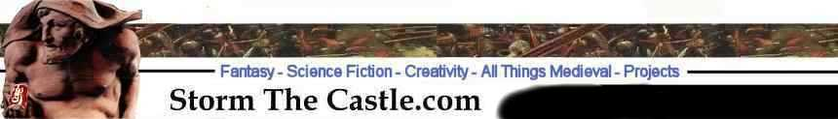

You are free to reproduce this game for personal use or to share with friends. You are not allowed to use this game in any format or any way with the intent of making money. You can post this game to your webpage as long as you make no changes to it and the links remain intact. And you must post an active hyperlink on the webpage where it is located or referred to. Make the link to http://www.stormthecastle.com For any questions contact the webmaster at stormthecastle.com Copyright ©2009 Kalif Publishing, All Rights Reserved.

